**Tales with Gigi: https://www.youtube.com/watch?v=8uYY61R-HpI**

**(Dopo la visione del video, leggi, disegna e colora)**

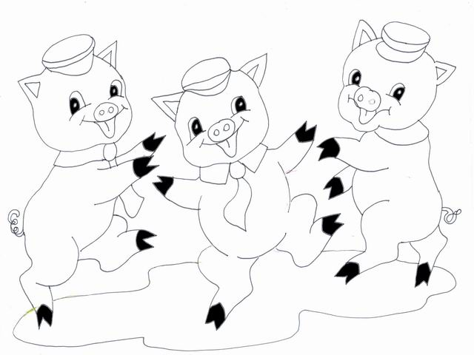**Bedtime fairy tale about anthropomorphic pigs who build three houses of different materials: straw, sticks and bricks. A bad wolf blows down the first two pigs' houses, but is unable to destroy the house made of bricks.**

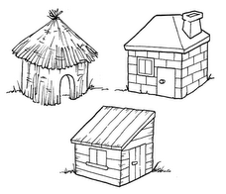

READ, DRAW THEN COLOUR

**Once upon a time there were 3 little pigs.**

**One day their mother said:**

**You are old enough to leave home!**

**So the three pigs left home and decided to build a house**

leave

**The first built his house of straw, the second built his house of sticks. The third built his house of brinks**

**The bad wolf huffed and puffed. The straw house and the sticks house fell down but he couldn’t blow the brinks house**